Clickup & Hubstaff integration



CONTENTS
1 Check Hubstaff Integrations 2
1.1 Linking projects 2
1.2 Unlinking projects 3
2 Track time in Hubstaff 3
2.1 Use Hubstaff desktop to track your time 3
2.2 Know what’s being tracked 4

Check Hubstaff Integrations
Hubstaff allows you to track time on ClickUp tasks and sync those time entries back to each task in ClickUp. The steps below show you how to integrate ClickUp with Hubstaff so your team can log time from the Hubstaff timer.

Linking projects
- Go to your Hubstaff page https://app.hubstaff.com/
- Click your profile icon (top-right) and select Integrations.
- Search for and select ClickUp.
- Click Next to grant Hubstaff access to your ClickUp account. You will not be prompted if you are already logged into ClickUp.
- Choose the ZTERS ClickUp Workspace and select Connect Workspace.
Tip: If your ZTERS account has already been set up, you will see ZTERS, Inc in the organizations list.

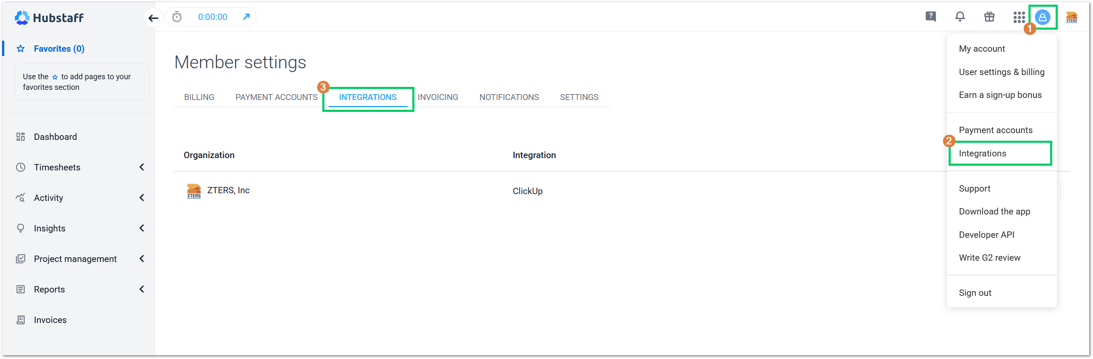
- Validate that the organization is linked to Hubstaff. If it’s not connected, the “Actions” drop-down menu will display the option to Authenticate it.
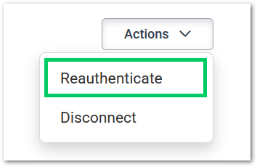

Unlinking projects
Warning: Un-linking and re-linking a project “disassociate” the tasks from the integration. So, if you unlink and relink a project you will end up with two copies of all those tasks, according to the official website.

To unlink projects, simply click on the integrations tab. Then, click the actions menu next to the project you’d like to unlink, and the Disconnect button will appear below.
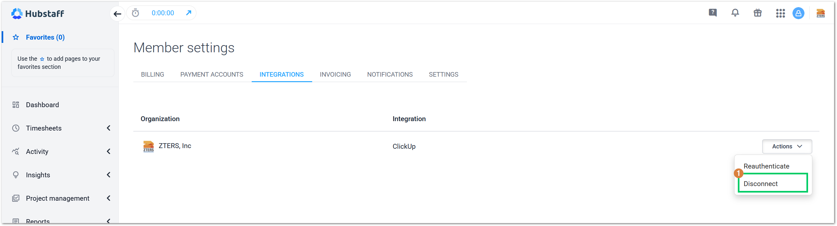
Once you have both your ClickUp and Hubstaff accounts linked, you can start tracking time for the different tasks you’ve been assigned to complete.

Track time in Hubstaff
Hubstaff works like a standard time clock on your computer. You start and stop the timer whenever needed, so tracking fits naturally into your workflow. Proof of work (screenshots, activity tracking, app/URL usage) is captured only when those features are enabled, and you have the timer running. To track your time in Hubstaff, follow the next steps:

Use Hubstaff desktop to track your time
- Download the Hubstaff desktop application https://hubstaff.com/download
- Install the application on your computer.
- Log into Hubstaff with your ZTER’s account.
- Search for your tasks in the left side pane of the Hubstaff desktop application. Most of your tasks will be in the Projects section, depending on your role.
- Select the “play/start” button next to a task to track time. The time tracked will then appear back in ClickUp task activity (as comments or time entries) depending on sync frequency.
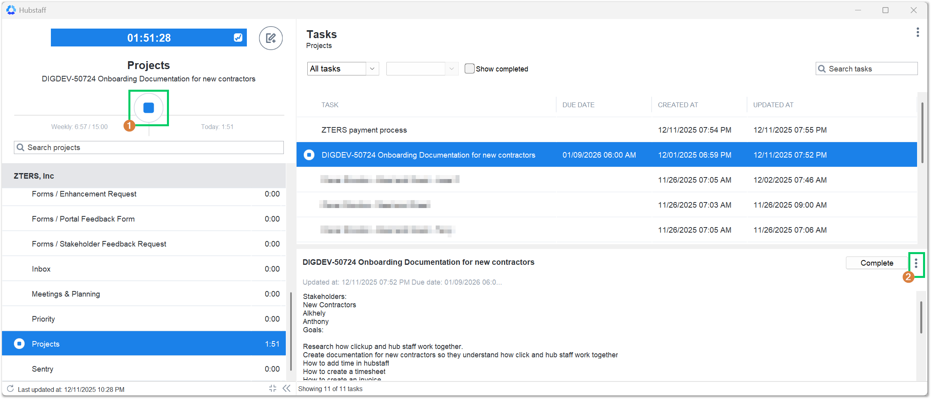

- Check the task in ClickUp by selecting the open task button, using the three (3) dot menu, on the left side of the window.
- Once your task is opened in ClickUp, you can manually change the card status according to the workflow for it.
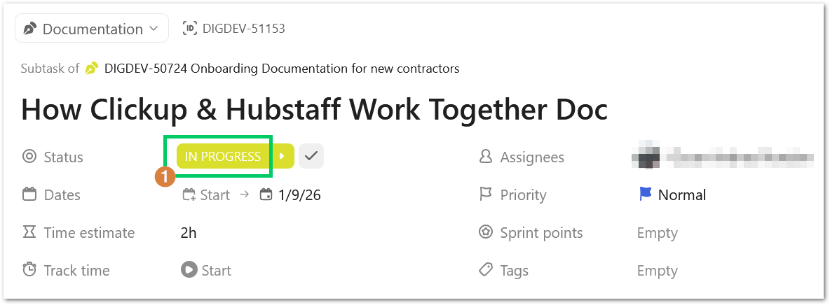
Warning: If you select the “Complete” button in Hubstaff desktop, the card task will automatically change to closed in ClickUp and will disappear from your tasks in Hubstaff. Keep this in mind, if you don’t want to finish the task yet.

Know what’s being tracked
Hubstaff is built to be fully transparent. You will receive notifications whenever the timer starts or stops and when screenshots are captured, ensuring you always know exactly when Hubstaff is active. The Hubstaff Dashboard gives users and managers a quick snapshot of productivity, time worked, and activity levels. To see it, follow the steps below:
- Log into your Hubstaff account https://app.hubstaff.com/
- Select the Dashboard option on the left side panel.
Tip: If your Hubstaff dashboard does not display anything, you will need to start tracking time to see some data on the screen.

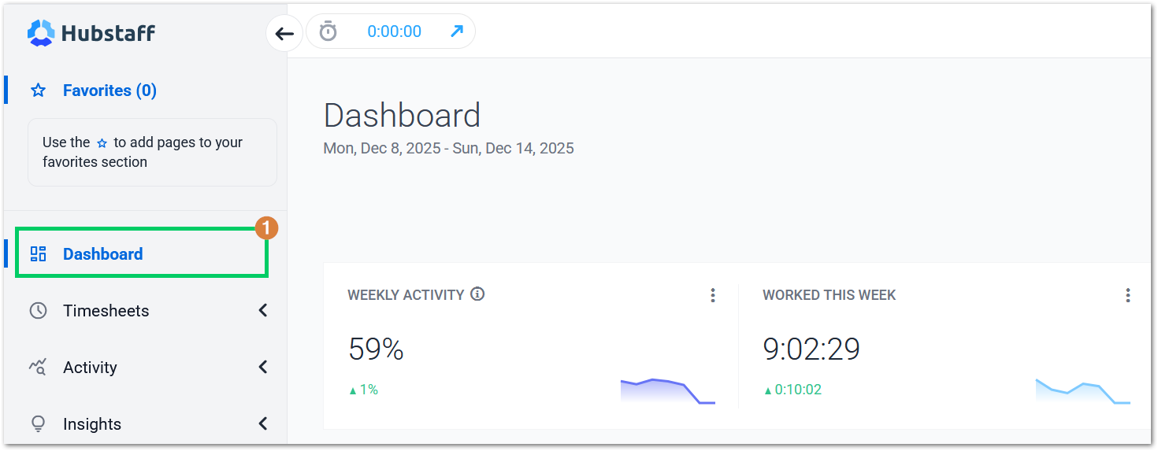
- Select the Timesheet option in the left side panel check the details of every one of your time entries in the system.
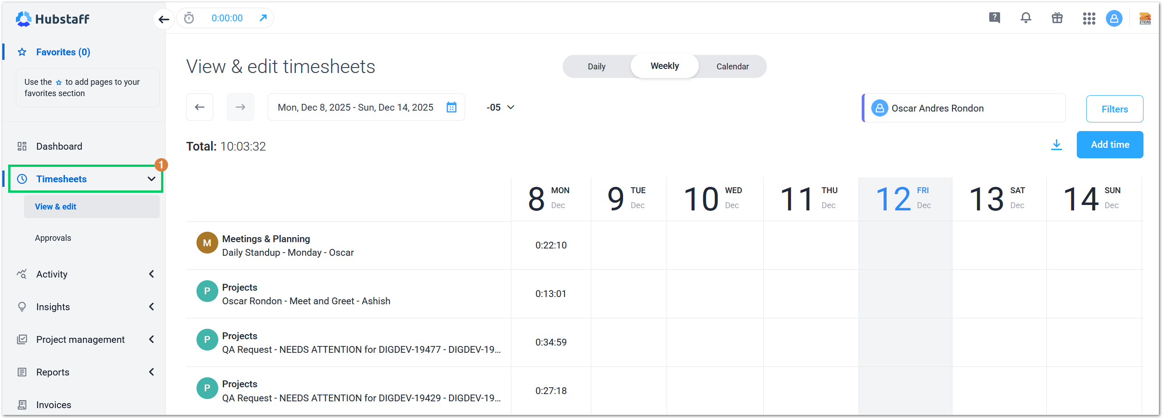

--- END OF THE DOCUMENT ---

